**DAILY ONLINE ACTIVITIES SUMMARY**

|  |  |  |  |  |
| --- | --- | --- | --- | --- |
| **Date:** | 15/07/2020 | **Name:** | JASLINE SHARON TAURO | |
| **Sem & Sec** | 4th sem,  A Section | **USN:** | 4AL18CS029 | |
| **Online Test Summary** | | | | |
| **Subject** | OPERATING SYSTEMS | | | |
| **Max. Marks** | 30 | **Score** | N/A | |
| **Certification Course Summary** | | | | |
| **Course** | Data Security | | | |
| **Certificate Provider** | SALES FORCE | **Duration:** | | 3 hrs |
| **Coding Challenges** | | | | |
| **Problem Statement:**  Given a stack, sort it using recursion. Use of any loop constructs like while, for. Etc is not allowed. | | | | |
| **Status:** | | Executed | | |
| **Uploaded the report in GitHub** | | YES | | |
| **If yes Repository name** | | <https://github.com/jaslinesharontauro/JAVA_Prgms> | | |
| **Uploaded the report in slack** | | YES | | |

**ONLINE TEST DETAILS:**

**Today we had an assessment in the subject “OPERATING SYSTEMS”. The test was based on the fourth module of the subject. The assessment was descriptive type and was consisting of four questions.**

**CERTIFICATION COURSE DETAILS:**

# Today I continued the course “Data Security” by Sales Force. Today I learnt about Data security and how to control access to orgs, fields, objects, records. I have completed the course.

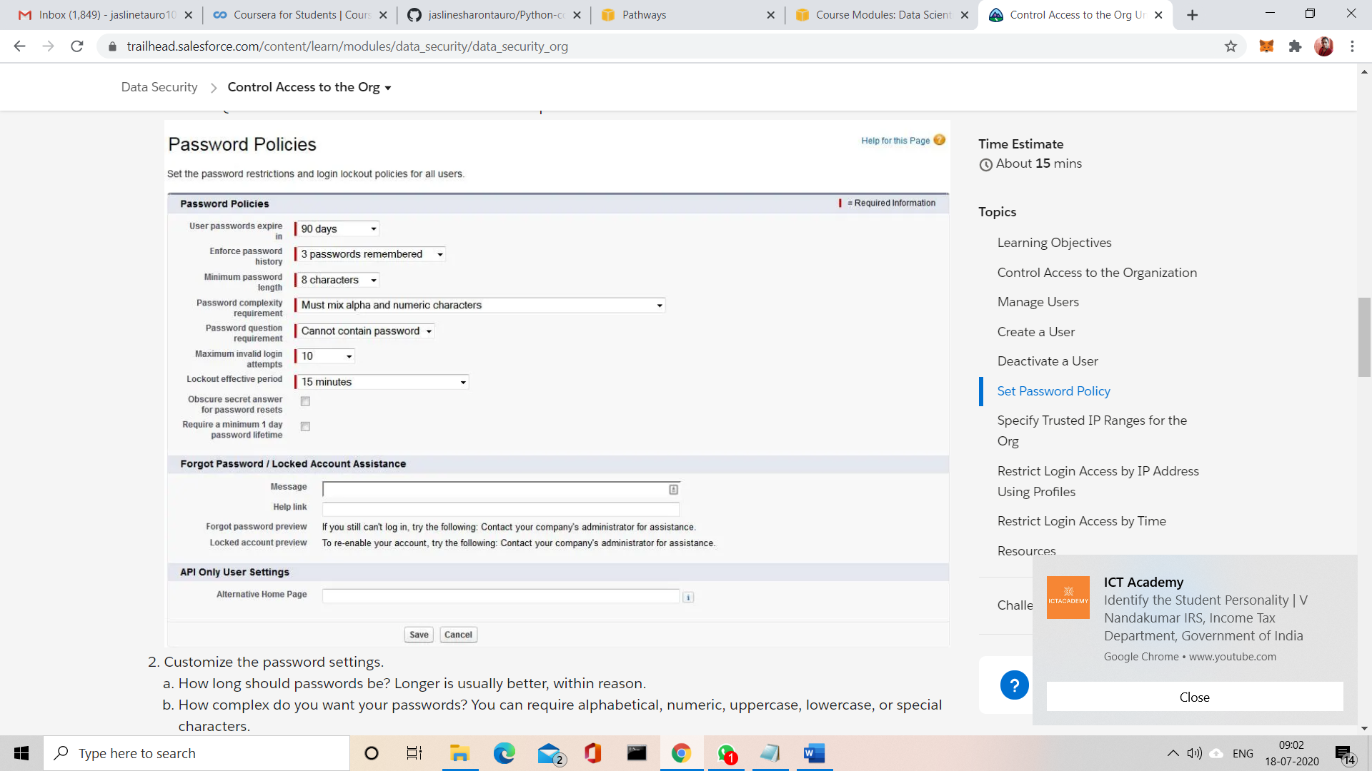

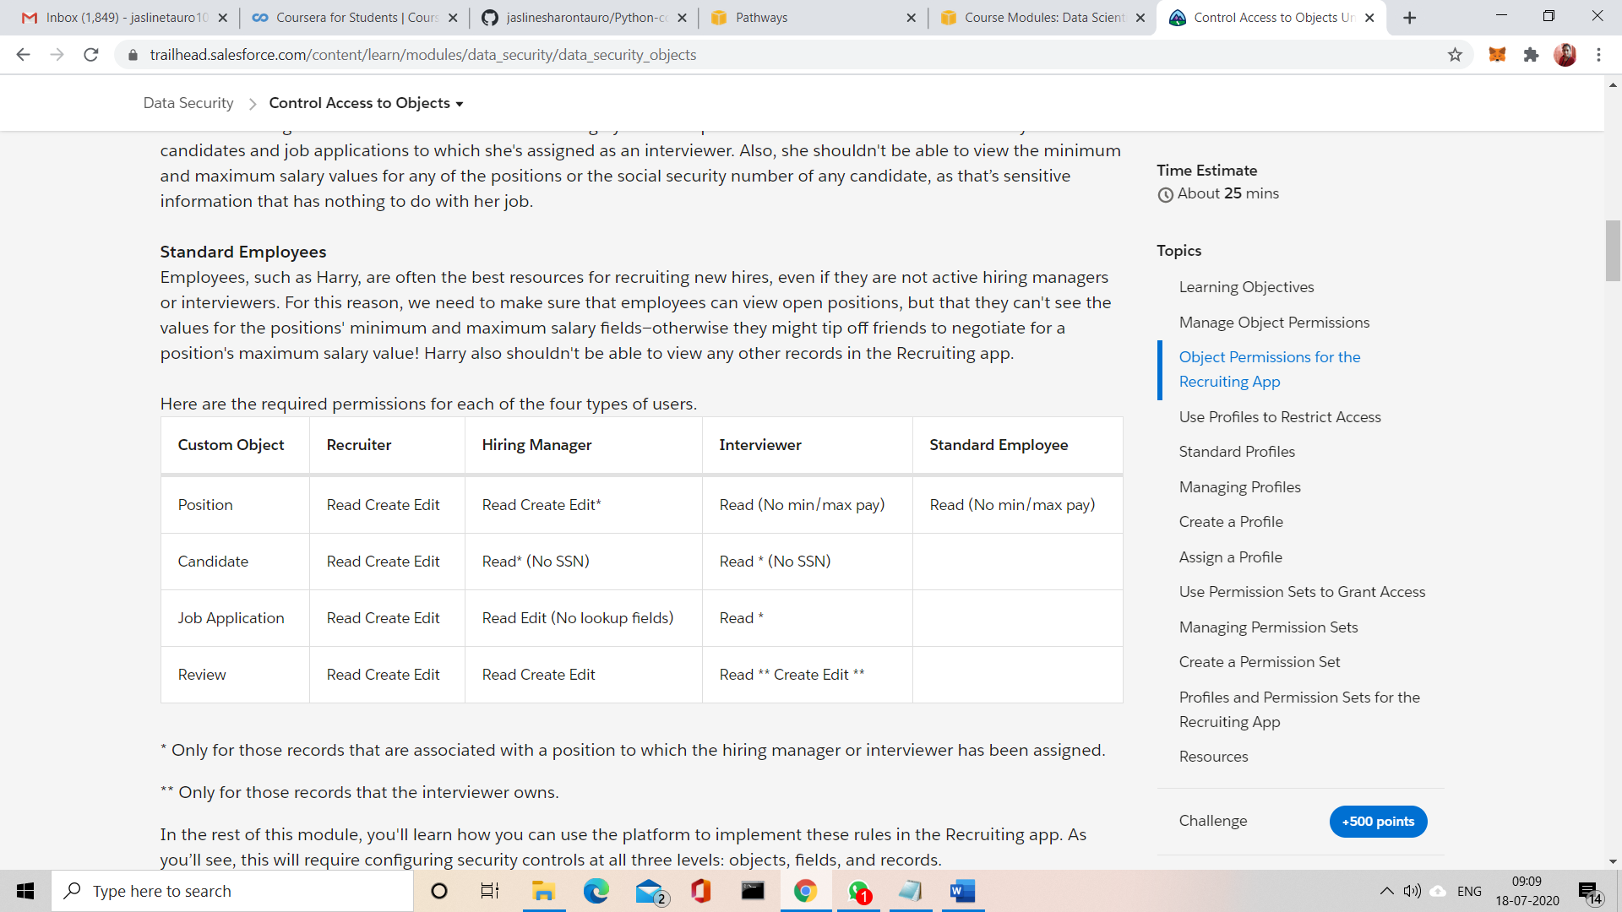

CODING CHALLENGES:

Problem Statement:

Sort a stack using recursion

Given a stack, sort it using recursion. Use of any loop constructs like while, for. Etc is not allowed. We can only use the following ADT functions on Stack S:

is empty(S): Tests whether stack is empty or not.

push(S): Adds new element to the stack.

pop(S): Removes top element from the stack.

top(S): Returns value of the top element.

Note that this function does not remove element from the stack.

Example:

Input: -3 <--- Top

14

18

-5

30

Output: 30 <--- Top

18

14

-3

-5

Solution uploaded in GitHub

